
Medical Journal of Tabriz University of Medical Sciences & Health Services
The Journal of Tabriz University of Medical Sciences & Health Services is an open access and Peer-reviewed multidisciplinary publication in Medical Sciences.
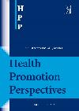
Health Promotion Perspectives (HPP)
Health Promotion Perspectives (HPP) is an international open access journal which provides a peer-reviewed multidisciplinary forum for the publication of research aimed at understanding the implications and approaches to health promotion in public health. This journal is open accessed and is published biannually...
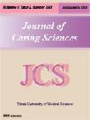
Journal of Caring Sciences (JCS)
The Journal of Caring Sciences (JCS) is a quarterly, Open access and Peer-reviewed multidisciplinary publication in Medical Sciences. The Editors welcome scholarly papers, addressing theoretical, empirical and methodological concerns and initiating dialogue on critical issues which contribute to the development and understanding of the caring sciences...
Journal of Clinical Research & Governance (JCRG)
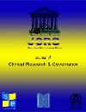
Journal of Clinical Research & Governance (JCRG) has been started through collaboration of scientific organizations, companies, and scientists from Sweden, Republic of Azerbaijan, Iraq, Iran, Egypt and few other countries. It is published by Swedish Science Pioneers. The aim of JCRG is to foster the exchange of information among the researchers engaged in clinical research or are working in field of clinical governance...
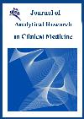
Journal of Analytical Research in Clinical Medicine (JARCM)
Journal of Analytical Research in Clinical Medicine (JARCM) is a peer-reviewed journal that publishes national and international articles. It was founded in 2013...
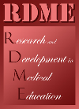
Research and Development in Medical Education (RDME)
Research and Development in Medical Education (RDME) is an open-access journal published bi-annual featuring peer-reviewed original articles, reviews, commentaries and reports in a wide range of areas related to medical and ...
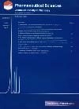
Pharmaceutical Sciences
Pharmaceutical Sciences provides a medium for the publication of research results in all areas of pharmaceutics, pharmacology, pharmacognosy, toxicology, medicinal chemistry, radiopharmacy, clinical pharmacy, hospital pharmacy, pharmaceutical nanotechnology, pharmaceutical biotechnology, echopharmacy, pharmacogenetics, pharmaceutical ethics, and water, food, drug, and cosmetic control...
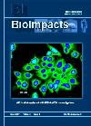
BioImpacts (BI)
BioImpacts (BI) is a peer-reviewed multidisciplinary international open access journal that covers original research articles, reviews, commentaries and visions/reflections dealing with all aspects of biological, biomedical and pharmaceutical researches at molecular, cellular and functional dimensions...
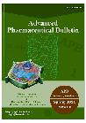
Advanced Pharmaceutical Bulletin (APB)
Advanced Pharmaceutical Bulletin (APB) is a peer-reviewed multidisciplinary international open access journal, covering a wide range of various integrative fields with Pharmaceutical sciences...
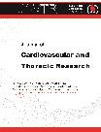
Journal of Cardiovascular and Thoracic Research (JCVTR)
Journal of Cardiovascular and Thoracic Research (JCVTR) is an international, open access and peer-reviewed journal published by Cardiovascular Research Center in Tabriz University of Medical Sciences. It covers all aspects of cardiovascular researches and accepts various types of scientific papers from letter and commentary to review and research...
Journal of Experimental and Clinical Neurosciences (JECNS)
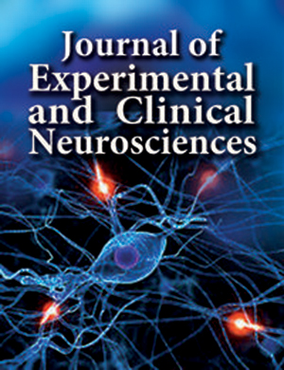
JECNS is a cover to cover translational or interdisciplinary neuroscience; however, top quality manuscripts (only manuscripts that make a significant addition to the literature) regarding experimental and clinical neurosciences are considered. JECNS is an open access journal that accepts all types of articles encompassing original research articles, review articles, case reports, short communications, and letters to editor. Currently, JECNS provides a grant to publish articles free of charge...
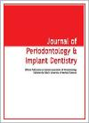
Journal of Periodontology & Implant Dentistry (JPID)
JPID is the official publication of Iranian Association of Periodontology, published by Tabriz University of Medical Sciences...

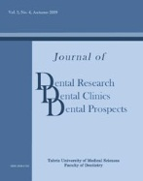
Journal of Dental Research, Dental Clinics, Dental Prospects (JODDD)
JODDD (triple d) is an open-access peer-reviewed journal devoted to dental sciences and related disciplines, published by the Faculty of Dentistry at Tabriz University of Medical Sciences...

